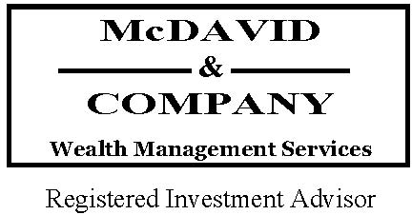 

Happy Summer America!

There is a lot to be positive about as we look out at the economic landscape. Corporate profits have grown steadily over the last year and we’re expecting more significant growth ahead. Well into a nearly decade-long economic recovery, U.S. stock earnings were given an immediate boost at the end of last year with tax reform pushing rates of growth substantially higher. While forward-looking earnings growth will not necessarily be as robust as the initial impact of tax savings wears off, growth has continued and may remain in the high single-digit or low double-digit range for another year or two based on mainstream economic analysis.

On Main Street, the economy is stronger than we’ve seen it for many years. Folks are back to work, unemployment is at record lows and businesses are expanding and hiring to keep up with demand. This is the real secret to the economy. All over the country--in fact all over the world--people are trying to make better lives for themselves and their families by growing their businesses, upgrading their skills for better opportunities, and purchasing the goods and services needed for these endeavors.

Of course, there are plenty of things to worry about right now as well. One big concern of late has to do with tariffs levied on foreign goods. One set has been implemented already and a larger new set has been announced, primarily concerning trade with China. After many decades of working to further free trade, we are now taking steps in the other direction. The administration indicates this will protect American businesses and that this is needed to further our national security.

The worry is that these actions will lead to an escalating round of tariff policies and that these extra costs will cause a drag on our own economy as people and businesses pay more for raw materials and manufactured goods. Only time will tell just what the economic impact of these policies will be, and that uncertainty is unsettling to markets and makes it hard for companies to do long-range planning.

We’ve seen a bit of that uncertainty play out with share prices since February. This year so far has certainly been a bumpier ride than the smooth sailing of last year. We would expect more volatility in the months ahead as the market debates tariff regimens, rising interest rates and their effect on economic growth and stock valuations.

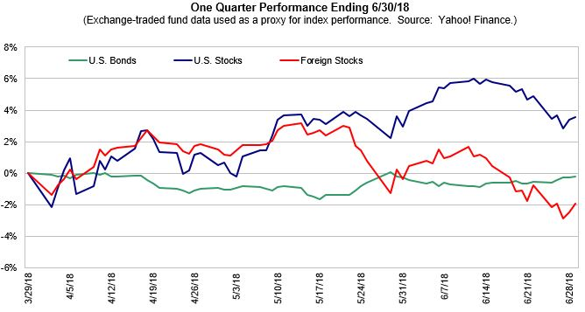

What is an investor to do? Diversification, coupled with a disciplined approach, continues to offer the best methodology for minimizing volatility while remaining invested in order to participate in the gains of the markets and economy.

In fact, we have seen this in action as we think about asset class results so far this year. Many would be surprised that U S equities are modestly positive year-to-date. Their international brethren, however, have not been as beneficial to US investors as a rising dollar has reduced returns to holders of those stocks here in the US. Interestingly, developed markets outperformed developing markets; this likely due to tariff fears. Real estate has had a great quarter after its lackluster performance in 2018, and commodities continue to lead, mostly due to higher oil prices.

Fixed income investments have had a less than robust showing so far this year as a focus on rising US interest rates put pressure on bond prices. This has been the most anticipated set of interest rate increases ever as we languished near zero on the short end for many years. So while rising rates have impacted bonds, the reaction to the rate increases thus far has been relatively modest. Longer term, this is a positive as it gives the Fed room to move during the next slowdown and also increases yields for bonds, which bodes well for this part of the portfolio in the years ahead.

It is always hard to tell just what the future holds, but we are optimistic with the economy still growing and inflation and interest rates at reasonable levels. There continues to be no sign of recession even as market pundits sharpen their gaze on the horizon ahead with this economic recovery in its 10th year.

We hope the rest of this year is rewarding for you and your family, and that you get to enjoy the best of what summer has to offer.

We hope you find the information in this newsletter useful, and always welcome your feedback.

Best regards,

 

